

The Homes for Ukraine Data Platform – Move on Process User Guide
Version: 1.0
Date of Release:
Contents
Acronym’s Section 3
The Move on Process 3
EOI’s and the Data Feed 4
LA / Contact Centre Responsibilities for the Move On Process 5
Contact Centre Responsibilities 5
Local Authority Responsibilities 5
Housing Need Section 6
Updating / Creating a Housing Need 6
Updating an existing Housing Need 7
Creating a new Housing Need 7
Host Address Section 8
Sponsor/ host checks 8
Host Address Related Checks 9
Adding an additional host address 10
Offered Property Tab 11
How to access the Host Record from the Offered Properties Tab 13
Searching for an Offered Property 15
Move On Search 16
Filtering the content of the view 17
Basic Editing of Filters 17
To Create More Specific Filters 18
Reservation Process 20
Reservation Status’ 22
If a match becomes unsuccessful 23
Creating PT’s when there is an active reservation. 24
If a PT is created with the local authority as outside of Wales: (outside of UK); (England) (Scotland): 24
Other Placement Types 24
If sponsor/host PT is selected: 24
If there is no active reservation: 25
If any other PT is selected: 25
To view all reserved hosts and properties that reside within your LA 26
Changes to the current process for linking a household record with a sponsor/host 26
Replacing an existing host / sponsor 27
Removing a host / sponsor 27
For No Shows 27
Match Process 27
Automatic creation of a new placement record 28
Matching within the same LA 28
Matching to a different LA 29
Rejected / Withdrawn Sponsors/Hosts 30
To reinstate a withdrawn host 31

Acronym’s Section

It is important to understand the terminology associated with the move on and overall HfU processes and to acknowledge the acronym’s associated with these:
Acronym | Phrase | Description
EOI | Expression of Interest | Someone who has reached out to the LA or WG to express they are interested in housing a Ukrainian citizen / family
IA | Initial Accommodation | Initial and temporary accommodation facilitated by the Welsh Government for applicants on the Welsh Super Sponsor scheme
WC | Welcome Centre | Previous term used for initial accommodation – for temporary accommodation provided by Welsh Government for applicants on the Welsh Super Sponsor scheme
UDP | Ukraine Data Platform | The data platform used to record all information regarding to both Welsh Super Sponsor and Individual Sponsor applicants

The Move on Process

Prior to July 2023, the way in which we handled the move-on process was using a spreadsheet solution sitting in an Objective Connect environment to enable sharing.
Move-on functionality was previously not developed in UDP as at the time there was insufficient time to stand-up a solution and the UDP information governance restrictions hindered our ability to make the move-on data available across all local authorities.
The move-on process has become the key focus of the Ukraine programme. In closing Initial Accommodation (IA) and Welcome Centres (WC) the overarching aim is to move people from WC/IA accommodation to longer term accommodation including hosted accommodation. We are also looking to place new applicant arrivals directly into hosted accommodation to reduce use of initial accommodation.
There is now a more definitive need to incorporate the move on process into the UDP and by doing so will reduce data duplication, provide a more consistent approach to managing move-on, make processes easier and will provide us with a complete single source of the truth.
The new process, as such, will remain quite like the current process:
- EOI offers will need to be triaged by the local authority.
- All standard housing and DBS checks will need to be completed.
- Once checks have successfully been completed the property will be made available to all LA’s when searching.
- LA’s will be able to locate properties based on the criteria set out in the housing need for each household.
- A property can be reserved by any LA and once reserved, becomes unavailable to others that are using the move on search function.
- Once matching has been completed a placement tracking will be auto created.
New processes that will be introduced following the move into the UDP (on 5th July 2023) will be as follows:
- There will be no requirement to upload the EOI manually into the UDP and you will not be required to enter data previously received via Objective Connect (this will be made Read Only) . All EOI’s that come through the Welsh Government Homes for Ukraine smart survey will be automatically uploaded via a data load.
- The LA will be responsible for inputting information into a new ‘offered property’ tab which will help aid the search functionality.
- The new search functionality will ensure that only one property can be reserved at a time.

Please note:
- EOI’s that are matched outside of the smart survey, usually as a result of self-matching will still have to be manually uploaded to the platform.
- The move on process will also amalgamate ALL available hosts – not just EOI’s. This means that when a household leaves their hosted accommodation and the host is still willing to host another family, the LA can recycle this record to be used within the reservation process on the move on search tab.

EOI’s and the Data Feed

All data we receive from the EOI smart survey will automatically be uploaded into the UDP. The data will be split into two parts and will feed into the relevant sections.
- EOI data that relates to the host / host address will be uploaded into the system as a sponsor record for that host address. The sponsor will be created automatically based on the information generated from the smart survey and will sit with the local authority where the host address is located.
- EOI data that relates to the offer of the property will be separated and linked into the fields on the offered property tab within the host address section.
It will be the Local Authority’s responsibility to contact the proposed host to clarify the data and capture any missing information.

LA / Contact Centre Responsibilities for the Move On Process

Both the contact centre and each respective LA will have responsibilities within the UDP to ensure that the move on process runs smoothly.

Contact Centre Responsibilities

The Contact Centre’s responsibility within the move on process is to ensure that direct allocations for Super Sponsor applicants runs smoothly.
- The overarching concept of direct allocation to hosts includes allocating arrivals through the Welsh Government Super Sponsor Scheme to hosts prior to their arrival in Wales. People will travel directly to hosts on arrival in the UK rather than placed in initial accommodation. Directly allocating people reduces the demand on initial accommodation and the need for local authorities to move people on from initial accommodation.
- The Contact Centre will identify available host offers via the move on search. They will then liaise with local authorities to coordinate the direct allocations and matching people to suitable hosts. People will not be directly allocated to a host by the Contact Centre without the agreement of the receiving local authority. The intention is to directly allocate all new arrivals to hosts where suitable host offers are identified. People will be offered initial accommodation in the form of a Welcome Centre or holiday park where a suitable host is not available.
- The Contact Centre will liaise between hosts and guests regarding arrival and travel to Wales. The contact centre will also manage the reservation process via the UDP to ensure that household records are linked and moved to the owning Local Authority of the new host / host address once the reservation process has been completed.

Local Authority Responsibilities

Each local authority will need to ensure that they have completed the following.
For Households/Applicants:
- Every Household within their LA has a completed Housing Need Tab.
- When a person joins or leaves the household the Housing Need Tab is updated to reflect the new household set up.
- The household timeline is updated with any important (but non sensitive) notes regarding the household.
- When actioning the move on search the LA must do this from the household tab and should consider the household needs when filtering their search.
- When a property has been reserved the LA must liaise with the host address Local Authority (if this is different to their own)
- When a property has been reserved, process the reservation through the stages, via the reservation status dropdowns, until the match is complete – regardless of whether the property is in your LA or not.
For sponsors/hosts:
- For every Sponsor or host (EOI), all sponsor and household checks must be completed and toggled before the property is made available in the move on search.
- Keep track of each reserved property within your LA (by means a of a view)
- Keep track of any hosts and host addresses that become available after their applicants have vacated to conduct a triage call for potential further hosting responsibilities (accessed by means of a view)
- Liaise with LAs who reserve one of your properties for their household – to arrange meetings and travel.

Housing Need Section
The housing need section is now a tab within the household page. You will no longer access the housing need via the ‘Linked housing need’ field on the household page, this has been removed. Although the record may look the same, we have developed and added a few fields that will contribute to assisting the matching process.
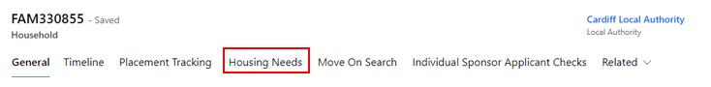

Updating / Creating a Housing Need

If a person joins or leaves a household ID group, you must:

- Update the linked housing need requirement for the existing household.
- Create a new housing need for the person that has been moved (if they are not joining another group).

Every Household ID, where the household is seeking new accommodation, should have a completed housing need tab which helps Local Authority colleagues when matching individuals to suitable accommodation, whether that be for individuals needing to be re-housed via the super sponsor scheme or for individuals who have arrived on the individual sponsor scheme.

Updating an existing Housing Need

- Go to the Applicants section and double-click on the name of an applicant to get to their individual applicant screen.
- On the Summary tab, click on the Household ID (FAM# or WG#).
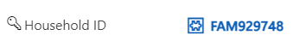
- On the Household screen click on the Housing Needs tab.

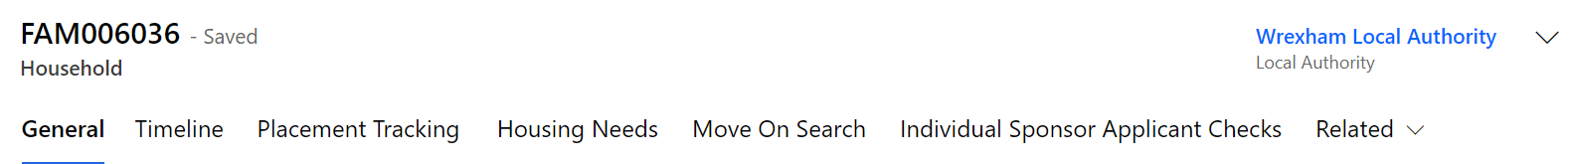

- Make changes to the fields as required. Those marked with a red asterisk (*) are mandatory.
- Once you have made the required changes, make sure to save by clicking the Save button or Save & Close button.

Creating a new Housing Need

- Go to the Applicants section and double-click on the name of an applicant to get to their individual applicant screen.
- On the Summary tab, click on the Household ID (FAM# or WG#).

This will take you to the Household section.
- On the Household screen click on the Housing Need tab – if there is no active housing need you will see the message: Source record not selected.
- You will need to click the Create Housing Needs button, which will show at the top of the household screen.
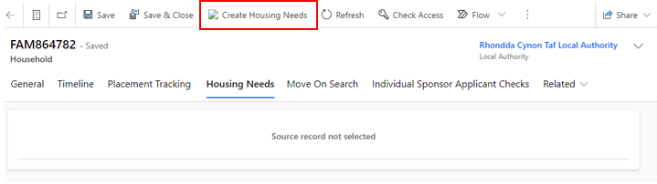

- You will then see a pop up confirming that a housing need will be created for the household – select ok.

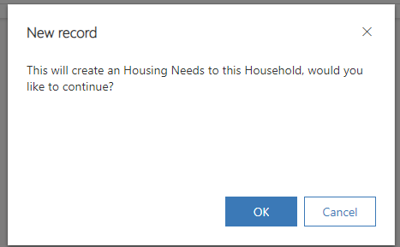
- This will generate a blank housing need screen.
- Complete the fields as required. Those marked with a red asterisk (*) are mandatory.
- Once you have made the required changes, make sure to save by clicking the Save button.
- As the Housing Need Record sits within its own tab, it will automatically link to the Household record.

Host Address Section

Sponsor/ host checks
The sponsor or prospective Host (EOI) and their property should be checked prior to arrival, or very shortly after, a person or household are matched to them. The sponsor check box (shown below) can be used to track when a check has been carried out. The two checks with padlocks will be provided the DLUHC data feeds and only apply to Sponsors, who have sponsored an application.
The checks should be toggled on the data platform once completed and include:
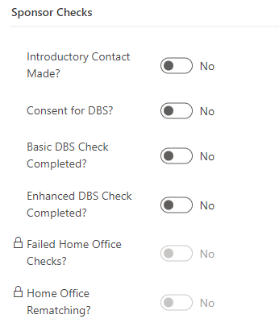
Introductory Contact Made – The LA has reached out to the host to make introductions, confirm they are still happy to host, provide all necessary information regarding the hosting and ensure they are prepared.

Consent for DBS – within the introductory contact the host should provide consent to start the DBS process, this will then either be completed by the individual or by the LA as per local processes.
Basic DBS Check Completed - to ensure that the Basic DBS check has been completed.
Enhanced DBS Check Completed - to ensure that the Enhanced DBS check (if required) has been completed.
Please note: only one DBS check needs to be completed, this is at the discretion of each LA as to which one, however it is recommended that an enhanced check be completed if the host is willing to house families with children or vulnerable adults.
Sponsor checks only: As part of the application process, a sponsor may be rejected by the home office if they fail their PNC (Police National Computer services) or Home Office Warnings Index Checks. This will be recorded in the data platform under a locked field on the sponsor record and will be read only for information only. It will be the Home Office’s responsibility to rematch the applicant to a suitable sponsor for their application, this will also show in the sponsor checks section under Home Office Rematching as a read only checkbox for information only.

Host Address Related Checks

The Host Address section has had some small changes made to ensure accurate data capture. On each host address record, you will see the housing inspection checkbox:

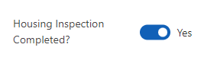
Housing Inspection Check - to ensure the property is suitable and meets the correct criteria to host applicants.
This has been removed from the Sponsor/Host section and will now sit on each individual host address record. The toggle will need completed for each individual property that the sponsor/host has offered once the checks have been confirmed successful.

Adding an additional host address
A host address is the address of the accommodation being offered to house applicants travelling to Wales. Occasionally, a host may have multiple addresses and may wish to offer a few of these to host within. The host may or may not live at these addresses.
To add a host address you need to:
- Click on the Sponsor section in left hand navigation and find the sponsor/host record required.
- Open the Sponsor/host record.
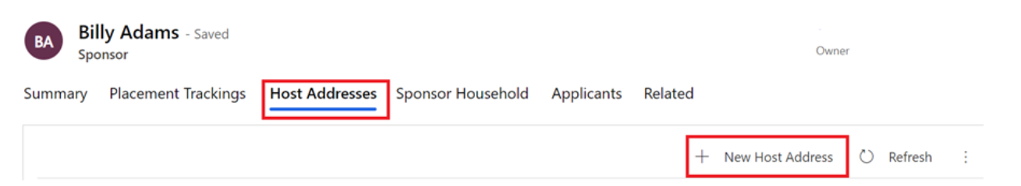
- Click on the Host Addresses Tab and click on New Host Address

- Complete the form, considering the following:
  - Address fields are for the accommodation that is being offered which may not necessarily be the address at which the host lives.
  - Staying with Sponsor field indicates whether the property is the main residence of the sponsor and their family e.g. someone would be allocated a room in the sponsors/host house rather than accommodation separately owned by the sponsor/host.
- Save the record.
- You now need to assign the host address records to ensure everyone in your local authority group can access the records - Select the address and click Assign Host Address.
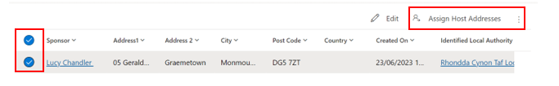
- Assign to User or Team and then hit enter to browse your local authority.
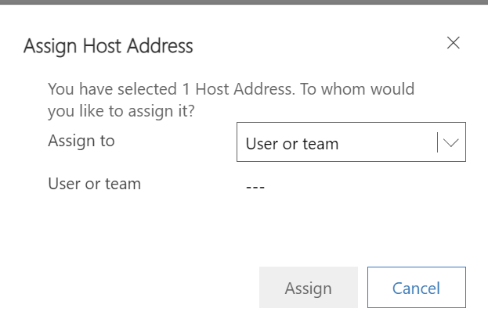
To check, this has happened correctly, you can check the host address to ensure the host local authority has changed as well as the ‘owner’ in the top right corner of the record. This may take a little while to filter through so refresh after 20 to 30 seconds.
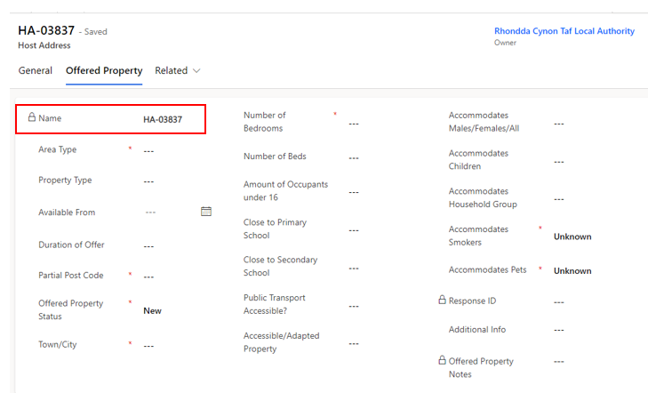
Creating a new host address will also create a new offered property tab. These two will be linked via the Host Address reference.

Offered Property Tab
The offered property tab sits within the host address section as a separate tab. This tab contains anonymised data and a partial postcode, to ensure that other LA’s access relevant data only.
The purpose of the offered property tab is to document the details of the property being offered, so that the Household property search shows viable properties only.
It is very important that this information is kept up to date and accurate to ensure that property searches across the board become successful reservations/matches.
The tab will include the following information, please complete the fields as required. Those marked with a red asterisk (*) are mandatory:
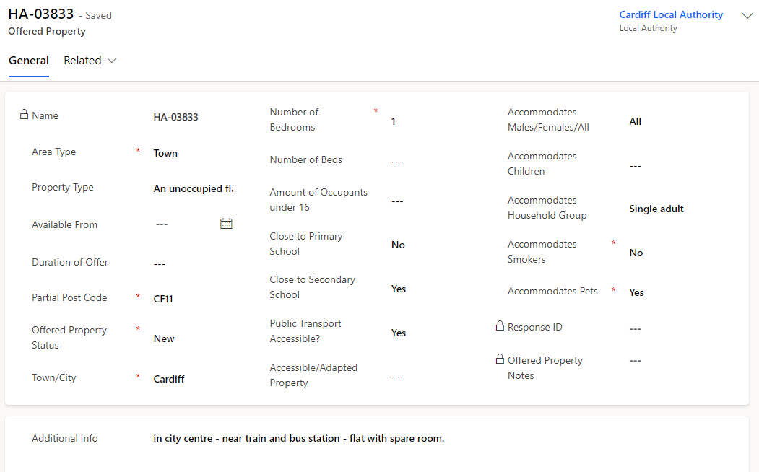
An offered property tab will appear automatically on any EOI data or when an additional address is added to a record. Existing sponsor records within the system that have an active hosting will still have an offered property tab but this will be empty and show ‘Source record not selected’:

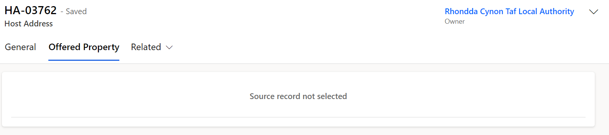
Once the current placement ends and the host address becomes available, the offered property status will revert to ‘Pending Checks’, and a blank offered property form will generate in the offered property tab. It will be your responsibility to communicate with the host to enquire if they wish to host another family. If they do, all previous checks should be confirmed to still be valid before making changing the offered property status to available.
Please note: If the host no longer wishes to house any new applicants, then their records need to be set to withdrawn and this will automatically set the offered property tab to removed.
To view all offered properties in your area you will need to access the Offered Properties tab via the left have navigation:
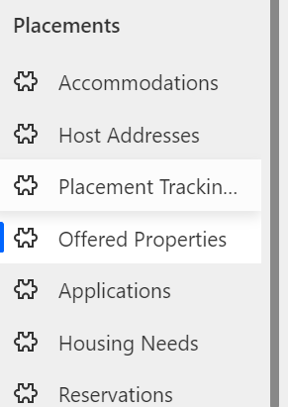
You can then access the view ‘My LA New / Pending Properties’ from the dropdown menu which will show all new offered properties and all properties currently pending checks.
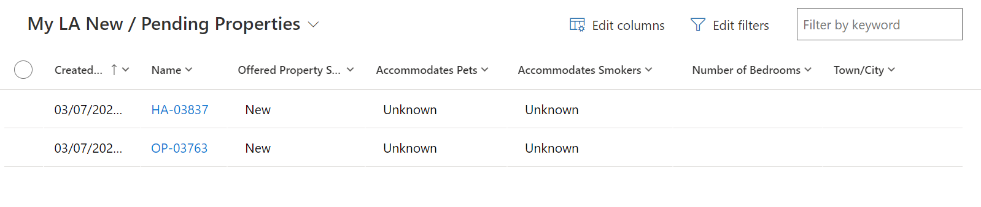
To access all Available properties in your area you need to select the ‘My LA Available Properties view:
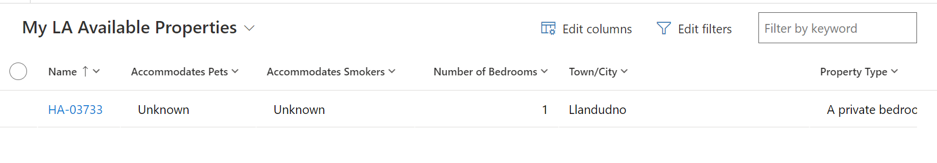

How to access the Host Record from the Offered Properties Tab

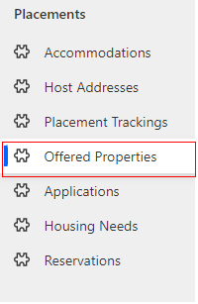
- Click into the Offered Properties Tab:

- Once you have selected the system view you wish to use, double click on the offered property you wish to access:
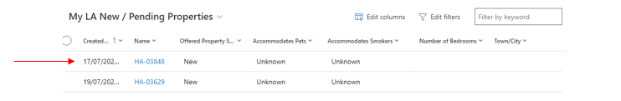

- Once in the record, select the Related dropdown and click Host Address:
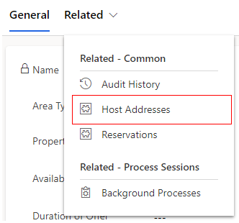

- When the Host Address Tab appears double click into the host address:
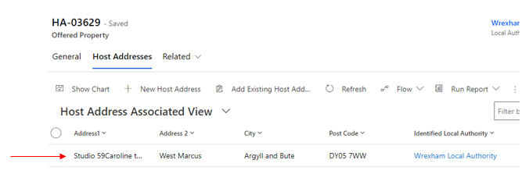

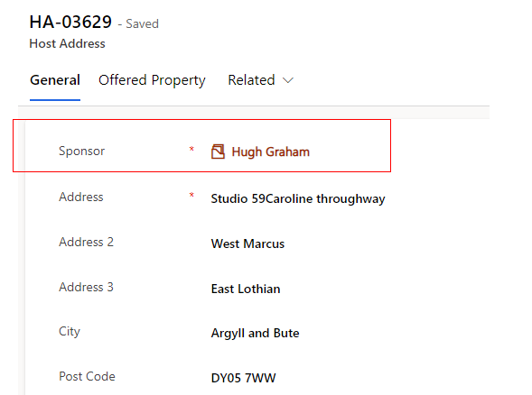
- Once in the Host Address record you will be able to see and click into the host name:
- You will then see the full sponsor / host record:
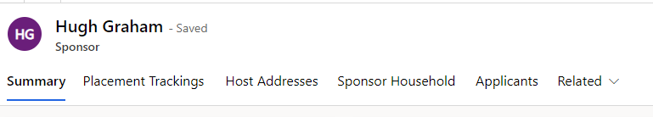

Searching for an Offered Property

Once all checks are complete on an EOI record, the offer becomes viable and the status will need to be changed from ‘pending checks’ to ‘available’ on the offered property tab.
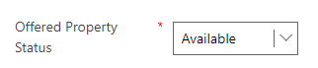

This means that the record will be viewable to all local authorities across Wales for them to reserve where appropriate.
It is imperative that the housing need tab is kept up to date to ensure an accurate search is carried out and the correct host / household match is made.
Each LA will be able to search for all available offered properties via the ‘move on search’ tab on the household record.
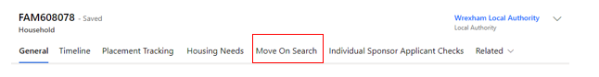

Move On Search

Within the Household Move On Search tab, each local authority will have access to the following view:
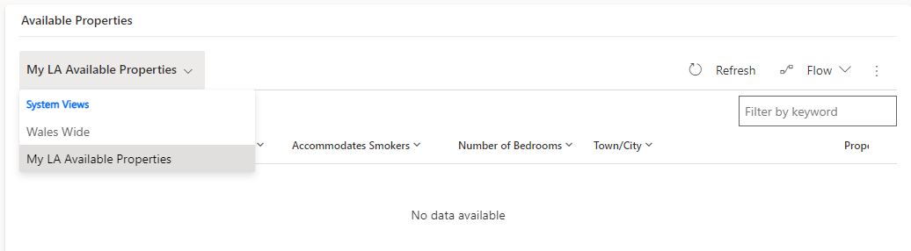

The view can show records from all local authorities across Wales in one table but also enables users to filter a few LA’s at one time or narrow the search down to one LA at a time. This will ensure that LA’s can tailor their initial findings based on area, which can either be across the whole of Wales or for a particular LA and its surrounding areas if required.
To search by the whole of Wales:
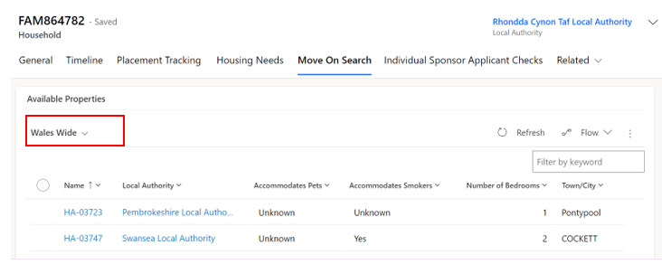
Select the Wales Wide drop down in the Available Properties table. This will show all available properties across every local authority within Wales. This view can be filtered to tailor the search to the household needs, including filtering to specific locations.

To search by individual LA:
Select the ‘My LA Available Properties’ drop down in the Available Properties table. This will show all available properties within your local authority only. This view can be filtered to tailor the search to the household needs.
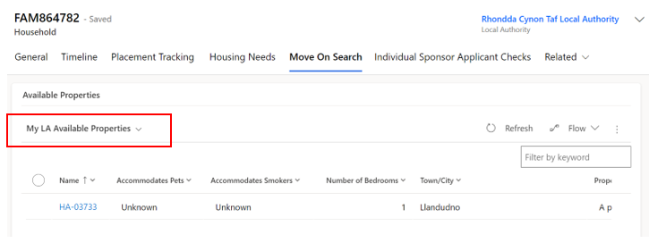

Filtering the content of the view
Each user can use filtering on each column to drill down on the criteria within the view to enable a more linear search of available properties. This will ensure that each category matches the criteria within the household housing need.
An example would be that for a household with two parents and one teenage child, you would filter the number of bedrooms to ‘Equals’ and then enter the value of 2 – meaning only 2 bedroom properties would show within the view.
Users can filter the view across all categories to manipulate the data and to ensure maximum accuracy in their property search.

Basic Editing of Filters

Users can add simple filters and/or sort the view directly from the columns. This can be done by either filtering on contained information within the view or sorting the view in alphabetical order. To do this you will need to:
- Go the column of the view you would like to filter.
- Click the downwards arrow tab
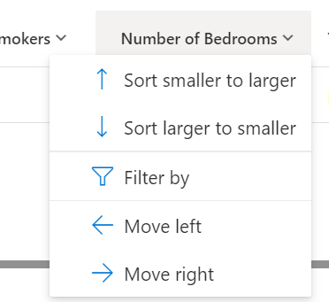
- To sort A-Z or Z-A / ‘smaller to larger’ or ‘larger to smaller’ the user can select which either dropdown is relevant.
- To filter the data, you can select the ‘filter by’ dropdown. 
  - You can then select from a range of dropdowns and correlating information to narrow down your search.
  - Once applied you will then see the funnel at the top of the column which indicates a filter has been applied 
- You can clear the filter by repeating the process of clicking the downwards arrow tab and selecting clear filter 

To Create More Specific Filters

To create more specific filters for the move on search such as showing only properties with a certain number of bedrooms, you will need to go to the ‘Offered Properties’ tab in the left-hand navigation.
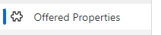
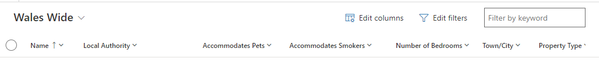
To add a new filter:

- Select the Edit filters button.
- Click the Add drop-down and choose to filter by Row, Group or Related Entity.
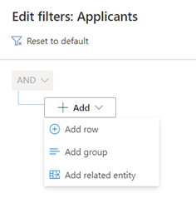
- Choose the row, group or entity you want to filter by (for example, Number of beds) and specify the criteria.
- Add more rows, groups or entities to filter by, or delete as applicable.
- Check the checkbox at the start of each row before attempting to apply your filters.
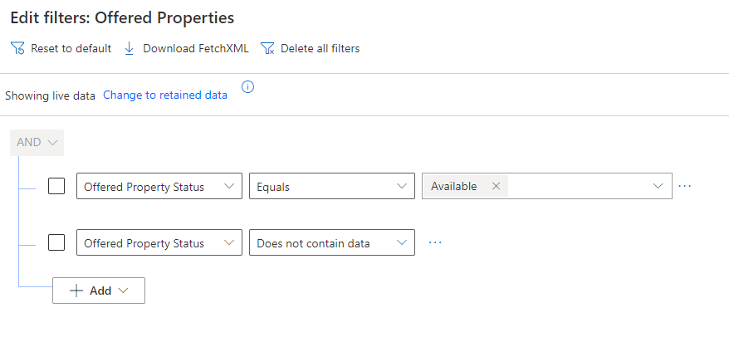
- Click the Apply button . This will filter the selection on your screen.

Once you are happy with your new filtered view you can save this as a new view which will then be available in the views on the move on search tab:

  - Click on the arrow next to the system view title.
  - A dropdown menu will appear.

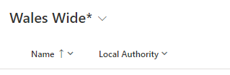

  - Click save as new view.

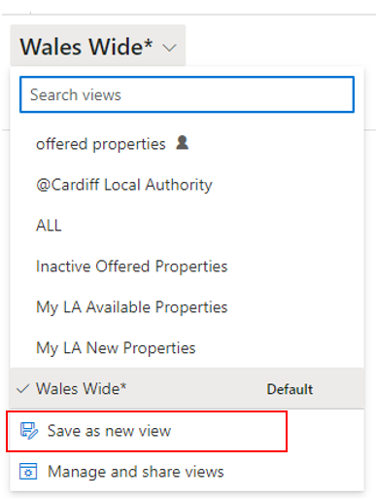

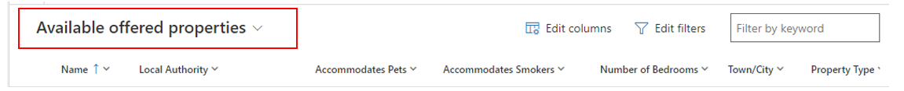
  - Edit the title of the view to what you want to call it.

  - This will now appear in the view’s dropdown on the move on search tab.

Reservation Process
Once a suitable property has been found you will need to follow the reservation process to ensure a match is completed successfully.
Reservation process:
- You will need to select the reservation by clicking the tick box on the left-hand side of the record in the list.
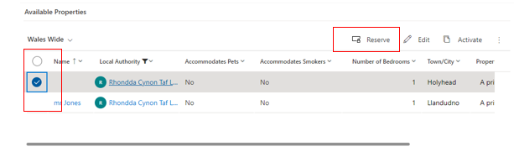
- You will then need to click the reserve button.
  - A pop-up window will confirm you wish to reserve the selected property - Click OK to reserve it.
  - You will see a ‘Reservation was created successfully’ message.
- This will remove the record from the available offered properties view and change its status to RS00 – New Reservation.
The reservation journey status will show on the record and will need to be updated as you move through the process.
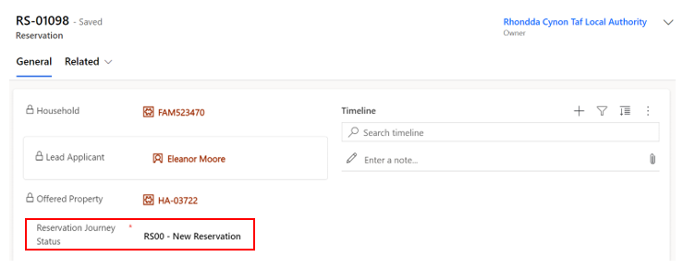
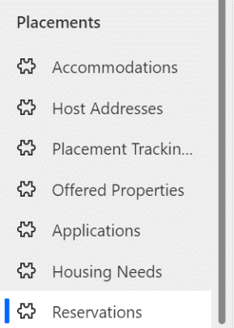
The reservation will move to the Reservations table which can be located on the left-hand navigation.

The reserving Local authority will be able to view all active and inactive reservations here depending on the dropdown selected. Once a reservation is complete the reservation will become inactive and move to the inactive reservation tab.
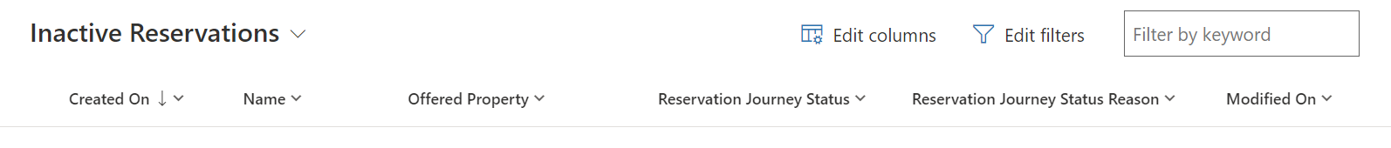
Please note:
If the reservation is within the same Local Authority then the user will have access to the household record, the host record and the reservation record.
If the reservation is requested for a property in another Local Authority only the requesting LA will see the reservation. Both LAs will need to communicate off the Data Platform to ensure that the reservation process is completed successfully.

Reservation Status’

Each stage of the reservation process requires a reservation status update. Certain reservation statuses will have influence over the automatic update of the offered property status.
An example of this would be when ‘RS02 – Host/Applicant introduction successful’ is selected, the offered property status will change from ‘Reserved’ to ‘Matched’.
It is important to understand what each reservations status means and its effect on the offered property status’.

Reservation Status | When should this be used | Impact on offered property status
RS00- New Reservation (Default) | This is the default status when a reservation is selected | Status remains as ‘Reserved’
RS01 - Applicant informed of reservation | The LA has reached out to the applicant to inform them of details of property / host / location etc and the applicant has accepted the reservation. At this point a meeting with host and household will be arranged. | Status remains as ‘Reserved’
RS02 - Host / Applicant introduction successful | The host and household have met, either in person or virtually and have both agreed they are happy to go ahead with the reservation. | Once selected the status will change from ‘Reserved’ to ‘Matched’
RS03 -Enhanced DBS check in progress | If the host has previously only completed a basic DBS check and now requires an enhanced check (because for example there will now be a child / vulnerable adult being hosted). This status will be selected once this process has started. | Status remains as ‘Matched’
RS04 - Enhanced DBS check complete | The enhanced DBS check has come back complete with no issues. | Status remains as ‘Matched’
RS05 – Date for move on confirmed | The LA has arranged between the two parties a date/time for the household to arrive at the new hosted property. | Status remains as ‘Matched’
RS06 – Travel to new host arranged | The LA/host has arranged travel for the household to arrive at the new hosted property. | Status remains as ‘Matched’
RS07 – Move on match complete | The household has successfully moved into the new hosted accommodation with no issues. | Once selected the status will change from ‘Matched’ to ‘Match Completed’
RS08 – Match Unsuccessful | The host/household match has fallen through (potentially because either or both parties have changed their mind) / the reservation was selected in error / the host has failed further DBS checks. | Once selected the status will change from ‘Reserved’ / ‘Matched’ to ‘Available’

If a match becomes unsuccessful

There may be occasions where a match is deemed unsuccessful. This may be due to the host or household changing their mind, it may be due to unsuitable accommodation/ location, or it may simply be that the property was reserved in error.
When this happens, you should:
- Make a note on the timeline explaining the reason for the match being unsuccessful (if necessary and remember to not include any sensitive information).
- Ensure both parties are aware that the reservation will be deleted.
- Set the reservation status to RS08 – Match Unsuccessful.
If RS08 – Match Unsuccessful is selected, then a sub status reason will appear. This will enable you to specify the reason for the unsuccessful match. This will ensure that no unnecessary information is inputted into the system and a generalised status reason is displayed. The status reason does not include detailed information of why the match was unsuccessful, it is for overview purposes only.
One of the following status reasons should be selected depending on the individual circumstances:
RS08 – Match Unsuccessful Status Reason | When should this be used?
Household rejected host | When the household has decided that the host / hosted property or location is not suitable for them. This should also be selected if a host has failed further DBS checks.
Host rejected Household | When the host has decided that the household is not suitable for them to host
Both parties in disagreement | When both the host and household agree that the hosting isn’t suitable for either party.
Property reserved in error | When a property has been reserved incorrectly and no action has been taken

Creating PT’s when there is an active reservation.

There may be occasions where a reservation is in progress and a family need to move temporarily to emergency accommodation until the new reservation is complete.
The system will allow a PT to be created whilst the reservation is in place providing the person is staying within the same LA. Once the reservation is completed the new PT will close the previous and pull in the new reservation and host details.

If a PT is created with the local authority as outside of Wales: (outside of UK); (England) (Scotland):

This may be due to the individuals repatriating or relocating. The system will prevent the PT from being created until the reservation has been closed. The below error message will appear:
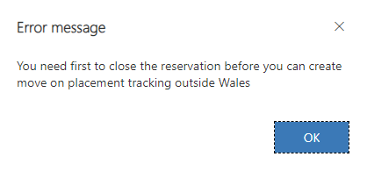

The reason this is blocked is to stop open reservations from being left in the system. If a reservation has fallen through because the household has decided to leave Wales this should be set to RS08 – match unsuccessful and the status reason, be set to ‘property reserved in error’ before a PT repatriation or move on (with England or Scotland as the LA) PT is created on the household.

Other Placement Types

If sponsor/host PT is selected:

If a sponsor/host Placement type is selected whilst there is an active reservation, the system will prevent the PT from being created:

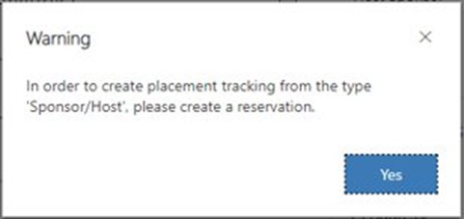

This is because the reservation process should be followed to create a sponsor/host PT.
Please note:
If there is a host already attached to the household (from a previous/ current placement) then until the reservation is set to 'Matched' - RS02 – RS06, a host/ sponsor placement tracking will still be able to be created but will link to the current host linked to the household page. Once the status is reflected to show the host / household as matched, the above error will appear preventing a PT from being created until the reservation process has been successfully completed.

If there is no active reservation:
If the reservation process hasn’t been started but there is a host attached to the household (from previous data load) and no PT has yet been created, the system will allow this to be created to reflect the current hosted placement.
When the time comes for the host to be changed, the reservation process should be followed.

If any other PT is selected:

If any of the below PTs are created whilst a reservation is in place, the system will allow the PT to be created provided that the local authority is within Wales:
- Hospital
- Move on accommodation
- Temporary accommodation
- Welcome Centre
- Temporarily Left
You should only need to create these placement tracking’s in emergency situations where someone needs to be relocated prior to the reservation process being completed.
If you are creating a placement tracking for a more permanent move that is not a host/sponsor placement created via the reservation process, you should close the active reservation before creating the PT.

To view all reserved hosts and properties that reside within your LA

Because the reserving LA has access to the reservation only, as the receiving LA you will have access to a system view that will ensure that you have sight of all reserved properties situated within your LA.
To access this view:
- Go to the offered properties tab (accessing via the left-hand Navigation)
- Select the view ‘My Offered Properties with an Active Reservation’ view

This will enable you to track the offered properties that have been reserved and what their current offered property statuses are.

Changes to the current process for linking a household record with a sponsor/host

Previously you were required to add a host to the household page and then create a placement tracking.
To make the connection between host and household you now need to follow and complete the reservation process via the move on search in the household tab.
The host / host address fields on the household are now locked fields and the information will filter through from the completion of the reservation process:
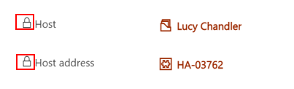

Replacing an existing host / sponsor

You will no longer have access to replace a host on the household page. The host / host address fields will be locked, and the reservation process needs to be followed to link a suitable host with a household.
Completing the reservation process automatically creates a new link between the new host and household alongside automatically creating the placement tracking. If there was a previous host linked to the household this process will replace that host and close all PTs associated with the previous hosting to free them up to potentially be available again.

Removing a host / sponsor

To remove a host/sponsor from a household who have moved out of hosted accommodation you will need to follow the process to create a placement tracking for anything other than host/sponsor.
When a new placement tracking record is created for any placement type other than ‘sponsor/host’ – the host details will automatically be removed from the Household page. The locked host field will remain locked prior to ending the current placement tracking and the creation of the new placement tracking will end the current sponsor/host placement tracking and remove that link to the host on the household.

For No Shows

When the IS or SS journey status is set to No Show (IS21- No Show – Known; IS22 No Show – Unknown; SS05D – No Show – Known; SS05E – No Show – Unknown) for all applicants within the household, any details in the locked host/host address fields on the household will automatically remove.
If one or more household members are not set to no show, the details will remain locked on the household page until all are changed to the no show status. It’s important to split the households if some applicants intend to travel and others don’t.

Match Process

Once the final steps for the reservation process have been completed you will need to:
  - Ensure all necessary timeline notes have been created.
  - Set the reservation status to RS07- Move on match complete.
  - Enter the start date for the move.
  - Click Save or Save & Close.

Automatic creation of a new placement record

Once the match process is completed successfully a placement tracking will be created whether this is within the same current LA or whether the new hosted arrangement is in a different LA.
The completed match process (setting the status to RS07- Move on match complete with the start date) will link the host and household together on the host section of the household tab. It will create a placement tracking on the household, applicant and sponsor records and will move the household into the new LA (if the household is moving from one LA to another). To confirm this has processed correctly you can go back into the household record and into placement tracking’s and view the new placement tracking records. If the household is moving to a new LA you will lose sight of the household record completely once you have entered the start date for the reservation.

Matching within the same LA

If the household and host both reside in your local authority, then the match process will mirror the reservation process:
- Find a suitable host by using the move on search.
- Reserve the host.
- Follow and complete the reservation process.
- Ensure all necessary timeline notes have been created.
Set the reservation status to RS07- Move on match complete.
- Set the start date as the first day of the new placement.
- Click Save or Save & Close.
Once the match process is completed successfully a placement tracking for ‘Sponsor/host’ will be created and will create the link between the host and household. The new host details replace any existing host details on the household and applicant records and the creation of the new placement tracking will close any previous placement tracking’s associated with these records.

If you are creating a placement tracking for any other option other than ‘sponsor/host’ for example ‘move on accommodation’ this will not pull through the host details into the placement tracking. It is important that you consider the below placement reasons and when to use them within a placement tracking record:

Placement Type | Reason for Placement Type | Additional Reasons | Additional Reasons 2
Hospital | When someone has left their accommodation to be hospitalised
Move on accommodation | When someone has left hosted accommodation to become self-supported | When someone has left one local authority to be hosted at another
Repatriation | When someone has left the UK entirely to return to Ukraine
Sponsor/Host | When someone is matched with a host - usually for the first time on the individual scheme | When someone is new to the local authority having moved from another LA in Wales to live with a chosen host
Temporary Accommodation | When someone arrives unexpected and is housed in initial accommodation (welcome centre) until a suitable host can be found | When someone needs to leave host address due to relationship breakdown and is moved to initial accommodation (welcome centre) | When someone needs to leave host address due to relationship breakdown and is moved to another host temporarily
Welcome Centre | When a person on the super sponsor scheme is housed in initial accommodation (welcome centre)
Temporarily Left | When a person has left their hosted accommodation for a short, temporary period for a holiday etc.  There will be a known return date and the case should be kept with the LA.

Matching to a different LA

If the household resides in your LA but the host resides in another local authority, you will need to follow the below steps:

- Find a suitable host by using the move on search.
- Reserve the host.
- Liaise with the receiving LA to follow and complete the reservation process.
- Ensure all necessary timeline notes have been created.
- Set the reservation status to RS07- Move on match complete.
- Set the start date as the first day of the new placement (once confirmed with receiving LA)
- Click Save or Save & Close
At this point the current LA will lose access to the record(s) as these will be automatically transferred over to the new LA. The host will automatically be replaced with the new host on the household page, the current PT will end. It is important that you inform the new local authority the records have been transferred across.
The new local authority needs to:
- Check the records have been received correctly.
- Ensure all relevant information has been recorded.
- Complete any future check ins with the host and household.

Once the host has confirmed the move has taken place, complete the finance section of the host record.

Rejected / Withdrawn Sponsors/Hosts

There may be occasions where a sponsor/host wishes to withdraw their interest in hosting or is rejected because of failed checks, such as local government/ property checks.
If a host expresses that they wish to ‘withdraw’ from the scheme or is ‘rejected’ because of failed checks the record will need to be set to the correct sponsor journey status in order for the system to deactivate their records.

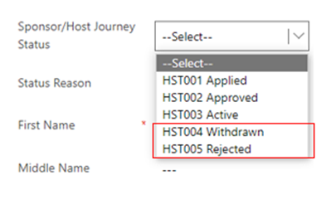
Once selected the system will automatically deactivate these records to prevent them from showing up on the active sponsors list.
- You will still have the ability to create case notes on the record once deactivated.
- The offered property tab for the host address will also become inactive and the offered property status will change to ‘removed’
- If you need to access a withdrawn / rejected sponsor record – you can locate these via the inactive sponsor’s view:
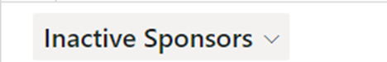

To reinstate a withdrawn host

If a host who has previously withdrawn from their responsibilities to host reaches out to state, they wish to begin hosting again you will need to obtain access of the previously deactivated sponsor/host record.

As local authorities don’t have access to reactivate records, data champions will need to contact the UDP team via the nationofsanctuarysurvey@gov.wales mailbox to request that the sponsor record be reinstated to an active status. Please include in your request:
- The name of the sponsor
- The action to be taken – status changed from HST004-withdrawn to HST003-Active
- A brief description that the sponsor has wished to resume their status as a host
The UDP team with then reactivate the sponsor/ host record and the offered property record. The offered property status will be changed to pending checks and it will be your responsibility to ensure that all sponsor/host checks are still relevant before making the property available within the move on search.

